**SUBNET CALCULATOR**

The Input Command For IP Subnet Calculator

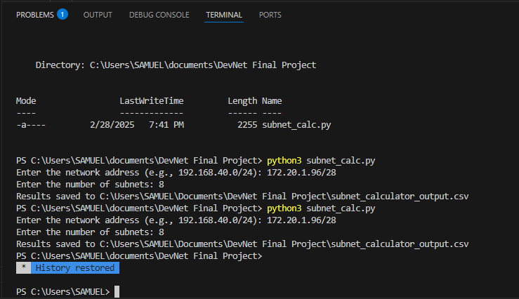  
  
  
The Output is as shown below in a separate CSV file.  
  
